History 279: Environmental Justice
GEP: Historical Perspectives and U.S. Diversity
Office Hours: TR 2-3pm | UWSP – History Department  Dr. Neil Prendergast  nprender@uwsp.edu

Why do some people suffer the effects of pollution more than others? That question guides this course, a history of the environmental justice movement. Students will learn how the civil rights movement and the environmental movement merged—at least some branches of the two—to form the environmental justice movement. Driving this resulting movement is the recognition that people marginalized socially, whether by race, class, or gender, often suffer from a disproportionate amount of environmental health hazards.

In this course, we will study the historical reasons for marginalization and how they played out spatially in the American landscape. We will then turn toward the fight against this environmental pattern, studying how marginalized Americans organized the environmental justice movement.

Enduring Understandings:

Conflicts over nature have had cultural and political dimensions.

Environmentalism has had a varied membership and an assortment of goals in American history.

Learning Outcomes: After taking this course, students will be able to:

- use primary sources to examine the environmental justice movement
- describe competing claims about the rise of the environmental justice movement
- analyze how environmental and civil rights concerns merged in the 20th century
- describe various dimensions of marginalization, particularly environmental injustice
- explain how the civil rights movement addressed environmental inequalities

p
Course Structure: To understand environmental justice, three historical patterns must be taken together: the civil rights movement; the environmentalism; and the growth of cities in the twentieth century.

Early in the semester, we will examine the African American migration from the rural South to the urban North. The migration was fueled by hope for a better life, and we will read about the African American push for parks and healthy neighborhoods that exemplified this hope. Likewise, we will look at the workplace of northern factories that undergirded this American dream. Unfortunately, in these factories and neighborhoods, twentieth-century African Americans faced pollution that threatened health and community.

As the semester progresses, we will examine how the reaction to this environmental injustice came as the civil rights movement matured and environmentalism widened. The resulting environmental justice movement fought its battles in the context of new civil rights and environmental laws, and the movement’s successes and failures are our final focus.

Office Hours: You are welcome to visit me in my office. I set aside office hours so that I have the chance to talk with students one-on-one. During that time, I do not have any other commitments. My only commitment is to speak with my students.

To visit me during office hours you do not need an appointment. We can chat about anything going on in the course, from content to class dynamics. They are an especially good time to check in if you missed class. (Office hours are not in any way, shape, or form akin to a visit to the principal’s office in high school!) If you have class or work during my office hours, I am happy to make an appointment so that we can still speak. Just email me.

Purchase Book: Brian McCammack, Landscapes of Hope: Nature and the Great Migration in Chicago (Cambridge: Harvard University Press, 2018).

E-Book via Library: Andrew Hurley, Environmental Inequalities: Class, Race, and Industrial Pollution in Gary, Indiana, 1945-1980 (Chapel Hill: University of North Carolina Press, 1995).

Text Rental Book: Christopher Wells, editor, Environmental Justice in Postwar America: A Documentary Reader (Seattle: University of Washington Press, 2018).

Canvas: There will also be additional articles, book chapters, and other materials available on Canvas.

Assignments: There are three exams and one paper.  The exams include both multiple choice questions and a long written response to the unit’s overarching question.  The paper will be due at our final exam time. It will ask you to respond to common assumptions about justice and the environment. Details will be available in an assignment description. | 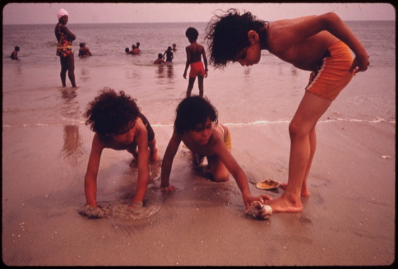

Grading: 4 exams @ 20 points each + Final Paper @ 20 points = 100 semester points.

A 93-100 | B+ 87-89.99 | C+ 77-79.99 | D+ 67-69.99 | F 59.99 and below
A- 90-92.99 | B 83-86.99 | C 73-76.99 | D 60-66.99
 | B- 80-82.99 | C- 70-72.99

 | 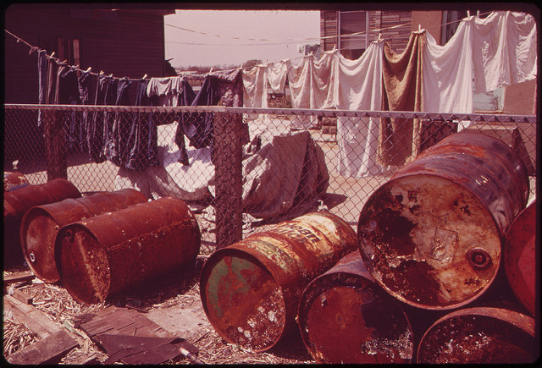 |  |  | Course Policies: For information on plagiarism, consult http://www.uwsp.edu/centers/rights.  See Chapter 14, Student Academic Standards and Disciplinary Procedures, pages 5 -10, for the disciplinary possibilities if you are caught cheating. As an instructor deeply concerned with fairness in the classroom, I pursue each and every case of plagiarism and cheating. Please note that turnitin.com is used for the essay assignments.
During the class, cell phones and other electronic devices are prohibited. If you are a parent or are otherwise obligated to be available to your family via cell phone, then please discuss that situation with me, so I know that you have a good reason for keeping your phone turned on.

The prohibition of electronics also extends to laptop computers (unless approved by the Disability Services Office). While laptops are great aides in studying, the focus in class is on class, not the computer screen. Further, the ability to take notes longhand is actually an important skill to develop, one that will be useful in any career you choose. If you do prefer to have your notes in a computer file, you will find that typing them from your handwritten notes will aid you greatly in digesting the material.

Equity of Educational Access: If you have a learning or physical challenge which requires classroom accommodation, please contact the UWSP Disability Services office with your documentation as early as possible in the semester. They will then notify me, in a confidential memo, of the accommodations that will facilitate your success in the course. Disability Services Office, 103 Student Services Center, Voice: (715) 346-3365, TTY: (715) 346-3362, http://www.uwsp.edu/special/disability/studentinfo.htm.

Note: The syllabus is a general plan for the course. Deviations announced in class may be necessary.

Schedule:
Week 1 |  | Wednesday 1/22 | In Class Reading: “Flint” |  | What is environmental justice?
 |  | Friday 1/24 | Canvas: “EJ in Chicago” |  | How does environmental justice matter today?
What types of places did African Americans create in the urban north—and why?

Week 2 |  | Monday 1/27 | Canvas: “Reconstruction”  EJPA: 29, 59. |  | What did inequality look like in the rural South a century ago?
 |  | Wednesday 1/29 | Canvas: “The Dark, Grey City” |  | What were the environmental conditions of the industrializing city?
 |  | Friday 1/31 | Landscapes of Hope, 15-30 |  | What was segregation like in northern, industrializing cities?
Week 3 |  | Monday 2/3 | Landscapes of Hope, 60-86. |  | What types of places did African Americans create to experience nature?
 |  | Wednesday 2/5 | Landscapes of Hope, 105-116. |  | How did parks matter for African Americans during the Depression?
 |  | Friday 2/7 | Landscapes of Hope, 176-185. |  | Why was camping important to black Americans in the Depression?
Week 4 |  | Monday 2/10 | Landscapes of Hope, 199-217. |  | Did the New Deal open possibilities for white and black Americans to share more places?
 |  | Wednesday 2/12 | Exam One
Friday 2/14
NO CLASS MEETING
How did environmental injustice become cemented into the American landscape?

Week 5 |  | Monday 2/17 | Canvas: “Color of Law”  EJPA, 33, 34, 36, 42 |  | In the postwar era, why did African Americans tend to stay in downtown neighborhoods while many white Americans left cities for suburbs?
 |  | Wednesday 2/19 | Canvas: “Selma of the North”  EJPA, 49, 50, 51, 53 |  | How did the civil rights movement address limits to where African Americans could live?
 |  | Friday 2/21 | Canvas: “Neighborhood”  EJPA, 30, 31, 99 |  | How did African Americans attempt to remake downtown neighborhoods in the postwar era?
Week 6 |  | Monday 2/24 | Canvas: “Troubled Waters in Ecotopia”  EJPA, 39 |  | What were the possibilities for public housing to remake African American neighborhoods?
 |  | Wednesday 2/26 | Canvas: “African American Automobility”  EJPA, 79, 81, 82, 85 |  | What limits did African Americans face in traveling to national parks and other outdoor destinations in the postwar era?
 |  | Friday 2/28 | Environmental Inequalities, 15-45  EJPA, 60, 62 |  | How did inequality in the workplace lead to vulnerability?
Week 7 |  | Monday 3/2 | Exam Two
How prepared were social movements to address environmental problems in postwar America?

 |  | Wednesday 3/4 | Environmental Inequalities, 111-135. |  | How prepared was the civil rights movement to address environmental problems?
 |  | Friday 3/6 | Environmental Inequalities, 46-76.  EJPA, 119 |  | To what degree did the environmental movement consider injustice in the 1960s?
Week 8 |  | Monday 3/9 | Canvas: “Rise of the American Conservation Movement” |  | What consideration did the earlier conservation movement give injustice?
 |  | Wednesday 3/11 | Canvas: “Forcing the Spring”  EJPA, 107, 112 |  | How did the environmental movement start to concern itself with human health?
 |  | Friday 3/13 |  |  | continued
Spring Break

Week 9 |  | Monday 3/23 | Canvas: “A Landscape Foreign and Threatening”  EJPA, 32, 97 |  | What unique problems did Mexican Americans face in midcentury?
 |  | Wednesday 3/25 | Canvas: “Trampling Out the Vintage” |  | How did the Mexican-American civil rights movement address environmental problems?
 |  | Friday 3/27 |  |  | continued
Week 10 |  | Monday 3/30 | Canvas: “As Long as the Grass Grows”  EJPA, 64 |  | What unique environmental problems did Native people face midcentury?
 |  | Wednesday 4/1 | Canvas: “Open Space”  EJPA, 93, 95 |  | How did Native people address environmental problems?
 |  | Friday 4/3 |  |  | continued
Week 11 |  | Monday 4/6 | Environmental Inequalities, 77-110. |  | How much a concern were environmental problems for the labor movement in midcentury?
 |  | Wednesday 4/8 | Canvas: “Dispossession” |  | What environmental problems did rural African Americans face in midcentury and how did they address them?
 |  | Friday 4/10 | Exam Three
What caused the environmental and civil rights movements to converge on environmental justice?

Week 12 |  | Monday 4/13 | Canvas: “First Along the River”  EJPA, 164 |  | What achievements did the environmental movement make that would matter for marginalized Americans?
 |  | Wednesday 4/15 | Canvas: “Love Canal”  EJPA, 124, 125 |  | How did working families push for even more environmental protections?
 |  | Friday 4/17 |  |  | Continued
Week 13 |  | Monday 4/20 | Canvas: “Transforming Environmentalism”  EJPA, 132, 134, 149 |  | How did African Americans in particular connect environmental and justice goals?
 |  | Wednesday 4/22 |  |  | continued
 |  | Friday 4/24 | Environmental Inequalities, 136-153.  EJPA, 170, 171, 178 |  | What challenged cooperation among Americans for environmental justice?
Week 14 |  | Monday 4/27 | Canvas: “Environmental Justice Today”  EJPA, 180, 183, 188, 194 |  | How has the environmental justice movement matured?
 |  | Wednesday 4/29 | Canvas: “Failed Promises”  EJPA, 198, 201, 206 |  | How successful has the environmental justice movement been?
 |  | Friday 5/1 | Exam Four
Final Paper: Countering Common Assumptions

Week 15 |  | Monday 5/4 | Final Paper Discussion
 |  | Wednesday 5/6 | Final Paper Workshop
 |  | Friday 5/8 | Final Paper Workshop
Final Paper due at end of Final Exam time.

